INFOTACT SOLUTIONS
Industrial Ai Division

Factory Guard AI
Manufacturing – Predictive Maintenance with Explainable AI (Tabular/IoT)

Project Report
Team Members
Member 1 - Manikala Madhavi.
Member2 - Preet Dudhat.
Member3 - Patel Grecy Vinod Bhai
Member4- Ram prasad Potu

Project Domain:
Domain: Manufacturing Industry
Project Type: Tabular Prediction (IoT / Time Series Data)

Contents
- Problem Statement ................................................. 2
- Objectives ............................................................... 2
- Dataset Description ............................................. 3
3.1 IoT Sensor Data Overview ................................... 3
3.2 Features Description ........................................... 3
- Data Preprocessing .............................................. 4
4.1 Handling Missing Values .................................... 4
4.2 Data Cleaning ...................................................... 4
4.3 Feature Scaling .................................................... 5
4.4 Train-Test Split .................................................... 5
- Feature Engineering ............................................ 6
- System Architecture ............................................ 6
7.Machine Learning Modeling Approach ............. 7
7.1 Model Selection (XGBoost, Random Forest) ... 7
7.2 Model Training ..................................................... 7
8.Model Evaluation ................................................. 8
8.1 Accuracy Score ..................................................... 8
8.2 Confusion Matrix ................................................. 8
8.3 Classification Report ............................................ 8
9.Explainable AI using SHAP .................................. 9
9.1 Feature Importance Analysis ............................. 9
9.2 SHAP Visualization ............................................. 9
10.Visualization and Results ................................... 10
11.Deployment (Optional) ...................................... 10
12.Conclusion ........................................................... 11
13.Future Scope ......................................................... 11

Problem Statement:
This project aims to predict machine failures in manufacturing industries using Machine Learning and IoT sensor data. The system uses Explainable AI (SHAP) to explain the reasons behind failure predictions. This helps industries reduce downtime, improve efficiency, and perform maintenance proactively.
Objectives:
The main objective of this project is to develop a predictive maintenance system using machine learning to predict machine failures in advance using IoT sensor data. This helps industries reduce unexpected breakdowns, minimize maintenance costs, and improve machine reliability. The project involves preprocessing sensor data, training machine learning models such as XGBoost and Random Forest, evaluating model performance, and identifying important features using SHAP. The trained model is then deployed using Flask to enable real-time machine failure prediction.
Dataset Description:
The dataset used in this project contains IoT sensor data collected from industrial machines. This data is used to predict whether a machine will fail or continue to operate normally. The dataset includes various sensor readings such as temperature, rotational speed, torque, and tool wear. These sensor values help the machine learning model understand the machine’s operating condition and identify patterns that indicate potential failure.
3.1 IoT Sensor Data Overview:
The dataset consists of multiple records collected from machine sensors during operation. Each record represents the condition of the machine at a specific time. The dataset includes both normal and failure conditions, which helps the model learn to distinguish between healthy and faulty machine states. This data simulates real-world industrial IoT environments where sensors continuously monitor machine performance.
3.2 Features Description:
The dataset contains several important features that describe machine behavior. These include air temperature, process temperature, rotational speed, torque, and tool wear. These features provide valuable information about the machine’s operational condition. Additionally, the dataset includes a target variable called "Machine Failure," which indicates whether a machine has failed or not. These features are used by the machine learning model to predict machine failure accurately.
4. Data Preprocessing:
Data preprocessing is an important step in building a machine learning model. The raw dataset may contain missing values, noise, or inconsistent data that can affect model performance. In this project, the dataset was cleaned and prepared by handling missing values, removing unnecessary data, scaling features, and splitting the dataset into training and testing sets. These steps help improve model accuracy and reliability.
4.1 Handling Missing Values:
Missing values can reduce the accuracy of the machine learning model. In this project, the dataset was checked for missing or null values. If any missing values were found, they were handled using appropriate methods such as removing incomplete records or filling them with suitable values. This ensures that the dataset is complete and ready for model training.

4.2 Data Cleaning:
Data cleaning involves removing duplicate records, correcting errors, and ensuring data consistency. In this project, unnecessary columns and duplicate entries were removed. The dataset was also checked for incorrect or invalid values. This step helps improve data quality and ensures better model performance.

4.3 Feature Scaling:
Feature scaling is used to normalize the values of different features so that they are on the same scale. This helps the machine learning model learn more effectively. In this project, standard scaling was applied to the dataset using StandardScaler. This improves model stability and accuracy.

4.4 Train-Test Split:
The dataset was divided into two parts: training data and testing data. The training data was used to train the machine learning model, and the testing data was used to evaluate its performance. In this project, 80% of the data was used for training and 20% was used for testing. This helps ensure that the model performs well on new and unseen data.

5. Feature Engineering
Feature engineering is the process of creating new and meaningful features from the existing sensor data to improve the performance of the machine learning model. In this project, important features such as rolling mean, exponential moving average (EMA), and statistical measures were created from the original IoT sensor readings. These new features help capture patterns and trends in machine behavior, which improves the model’s ability to predict machine failure accurately.

6. System Architecture
The system architecture represents the overall workflow of the predictive maintenance system. First, IoT sensors collect real-time data from industrial machines, such as temperature, torque, rotational speed, and tool wear. This data is then preprocessed to clean and prepare it for analysis. After preprocessing, machine learning models like XGBoost and Random Forest are trained to predict machine failures. Explainable AI techniques such as SHAP are used to identify important features affecting the prediction. Finally, the trained model is deployed using Flask API, allowing users to input sensor values and receive real-time machine failure predictions.
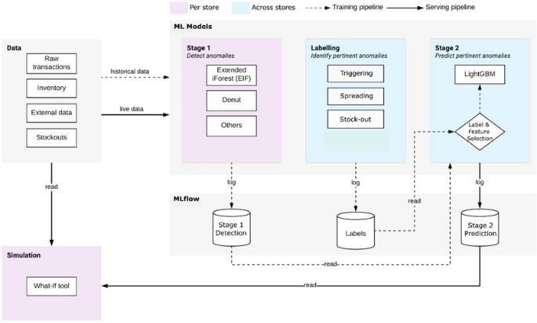

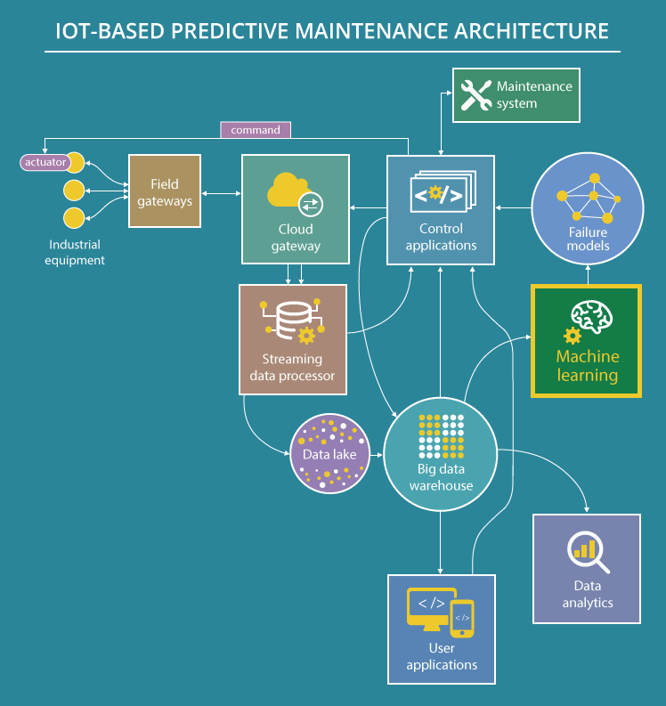

7. Machine Learning Modeling Approach:
This project uses machine learning algorithms to predict machine failure based on IoT sensor data. Models such as Random Forest and XGBoost were used because they provide high accuracy and handle complex patterns in data. These models learn from historical sensor data and identify patterns that indicate machine failure.

7.1 Model Selection (XGBoost, Random Forest):
Random Forest and XGBoost were selected because they are powerful classification algorithms. Random Forest works by combining multiple decision trees, while XGBoost improves prediction accuracy using boosting techniques. XGBoost was selected as the final model because it provided better performance.

7.2 Model Training:
The selected model was trained using the training dataset. During training, the model learns patterns from sensor data and builds a predictive model. After training, the model can predict whether a machine will fail or not.

Modeling Diagram
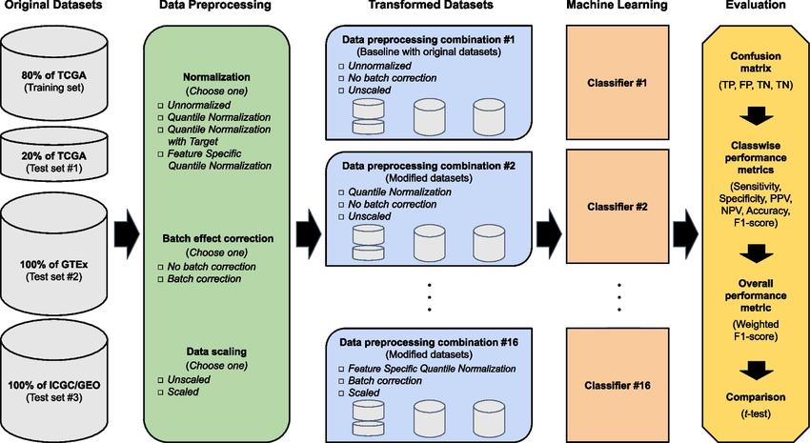
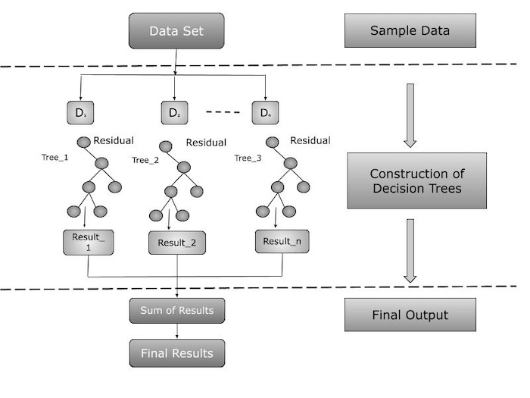
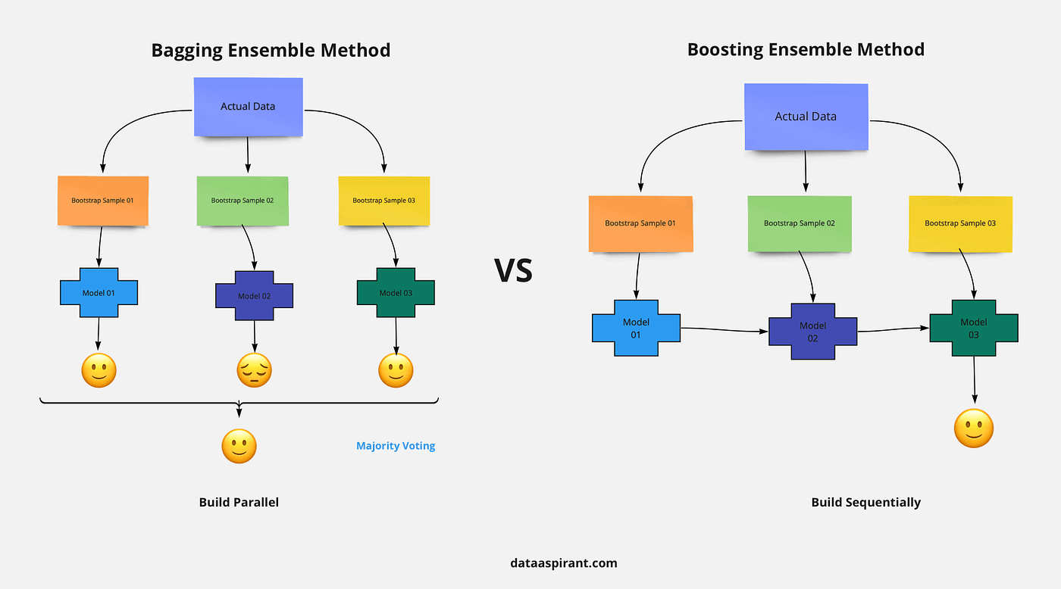
4

8. Model Evaluation:
Model evaluation is used to measure the performance of the trained model. Different evaluation metrics such as accuracy score, confusion matrix, and classification report were used to analyze model performance.

8.1 Accuracy Score:
Accuracy score measures how correctly the model predicts machine failure. A high accuracy score indicates good model performance.

8.2 Confusion Matrix
Confusion matrix shows correct and incorrect predictions made by the model. It helps understand model performance in detail.

8.3 Classification Report
Classification report provides detailed evaluation metrics such as precision, recall, and F1-score.

Evaluation Diagram
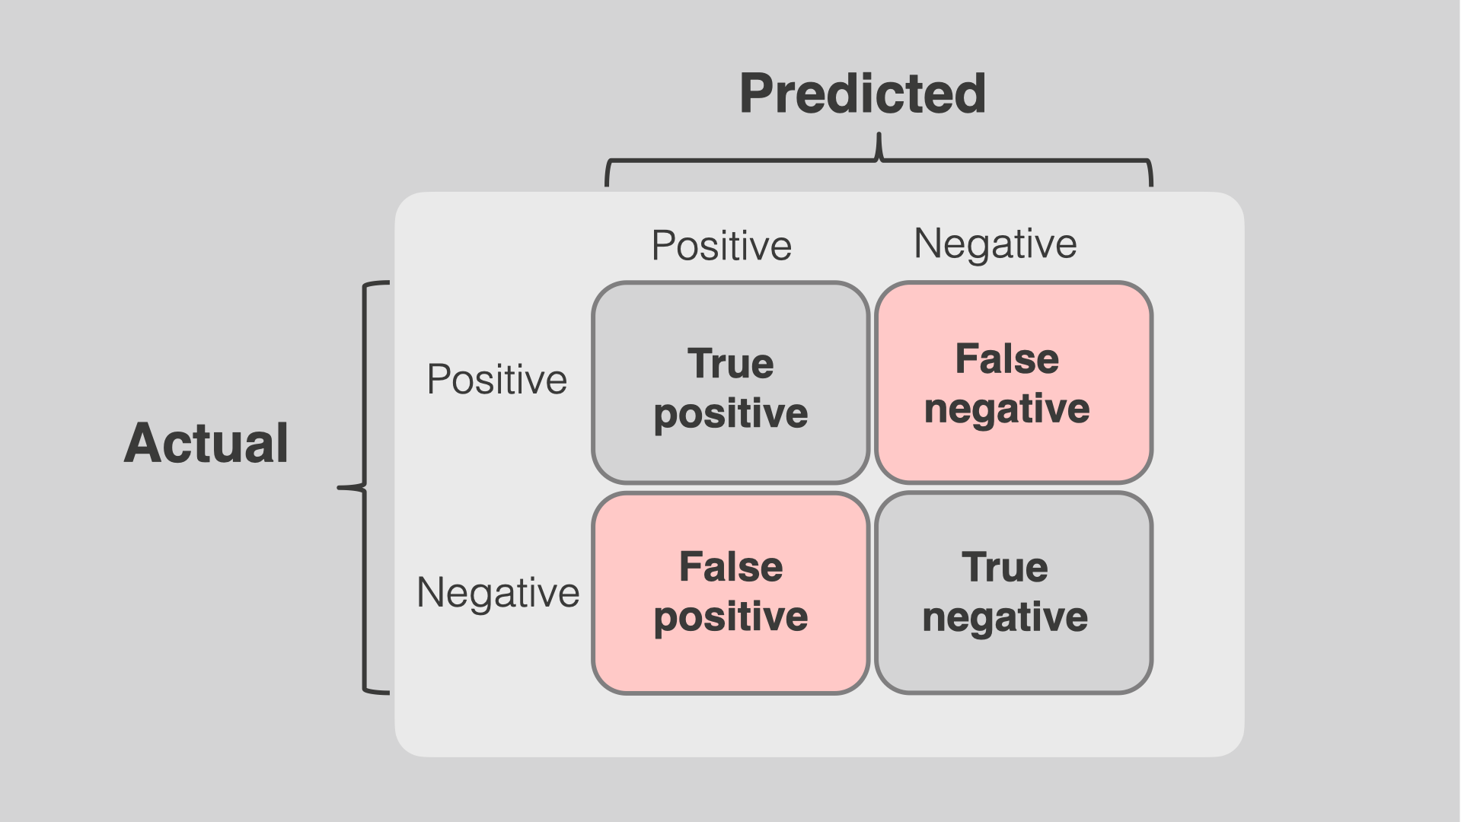
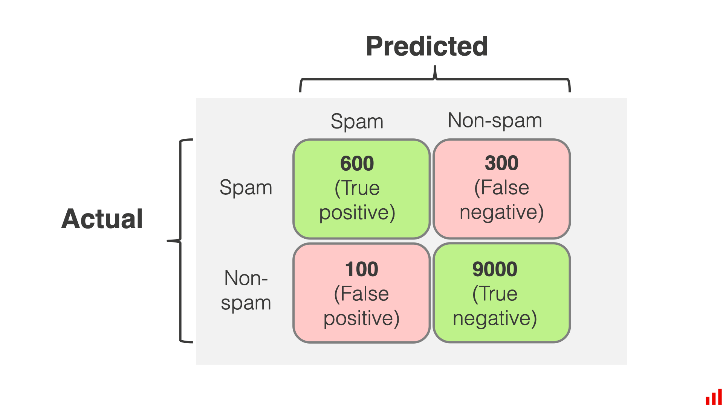
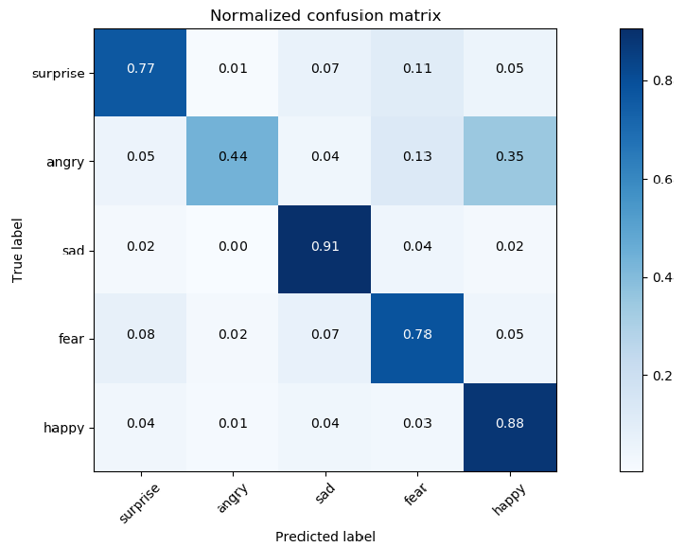
4

9. Explainable AI using SHAP
Explainable AI helps understand how the model makes predictions. SHAP (SHapley Additive important features affecting machine failure prediction.Explanations) was used to identify

9.1 Feature Importance Analysis:
SHAP identifies which sensor features have the highest impact on prediction. Important features help understand machine behavior.

9.2 SHAP Visualization:
SHAP visualization shows how each feature contributes to the model’s prediction.

SHAP Diagram
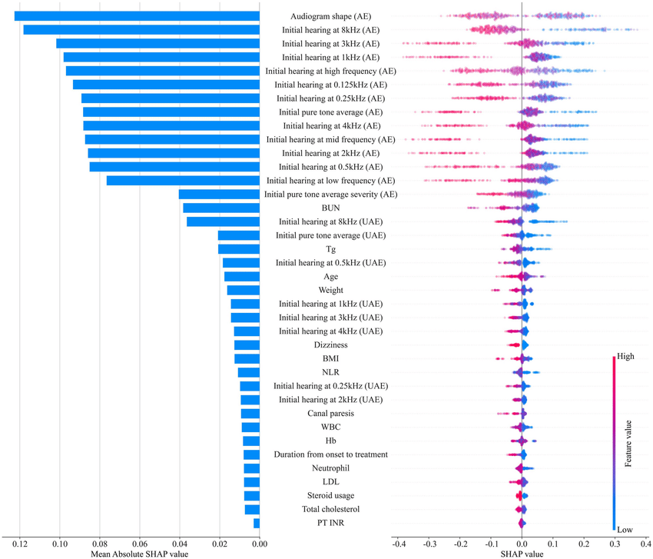
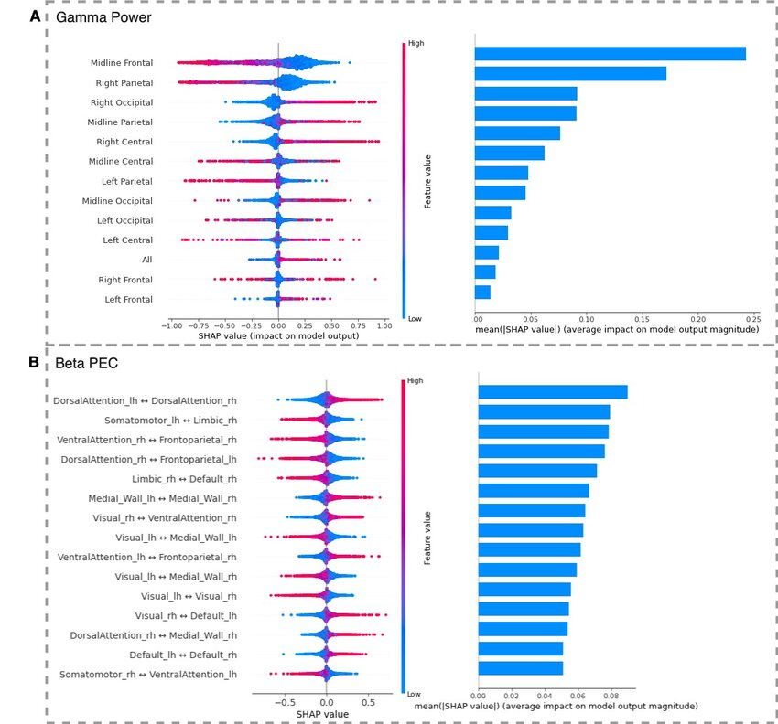
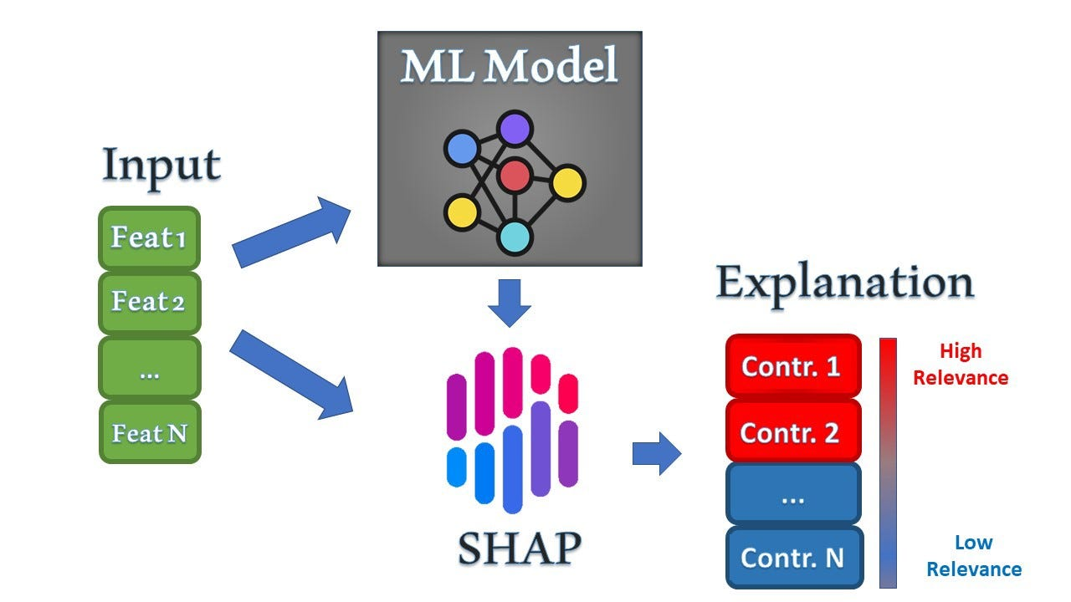
4

10. Visualization and Results
Visualization helps understand model performance using graphs and plots. Feature importance plots, accuracy graphs, and SHAP plots were used to analyze results. These visualizations show how well the model performs.

Visualization Diagram
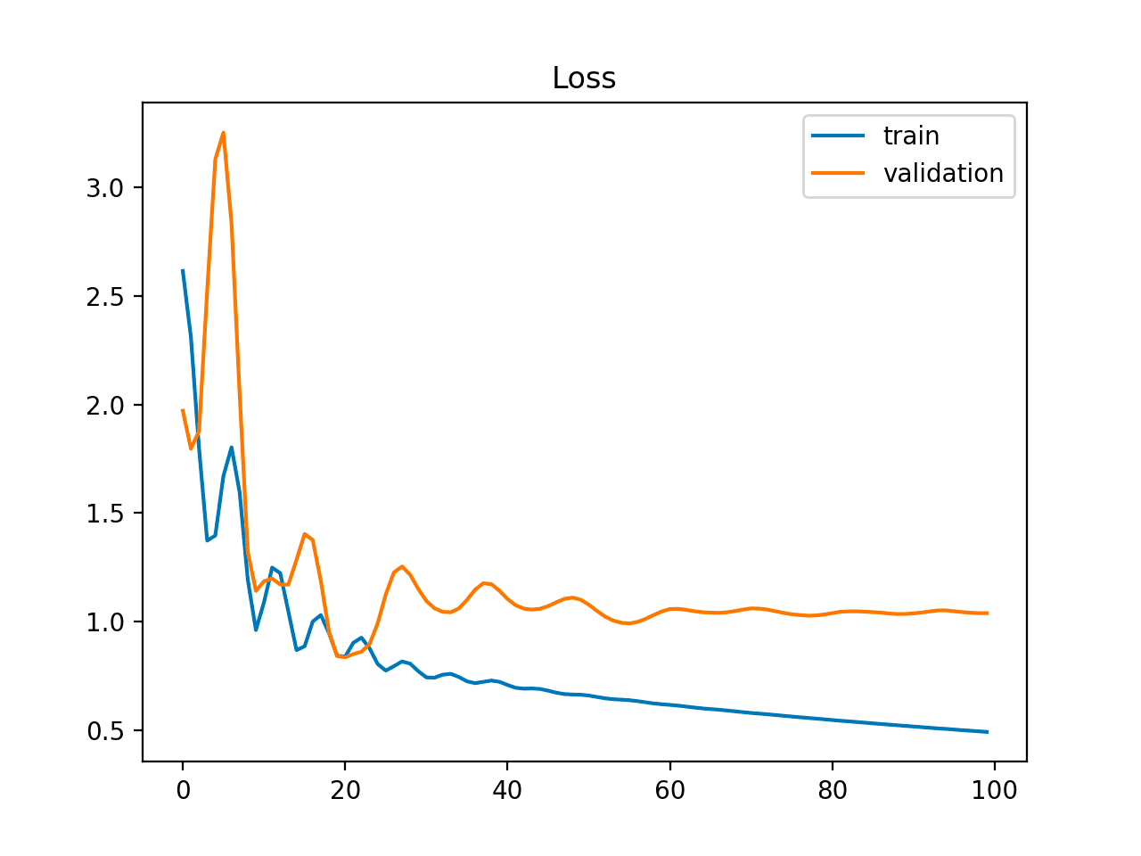
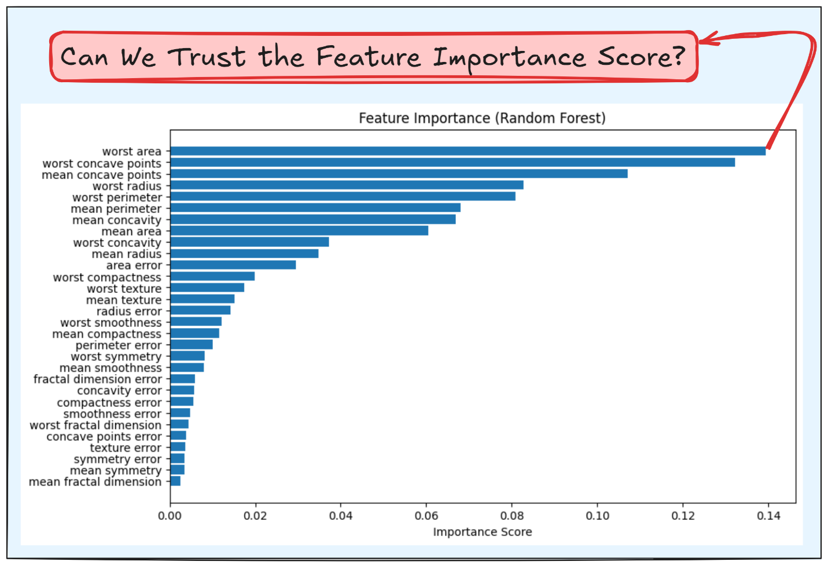
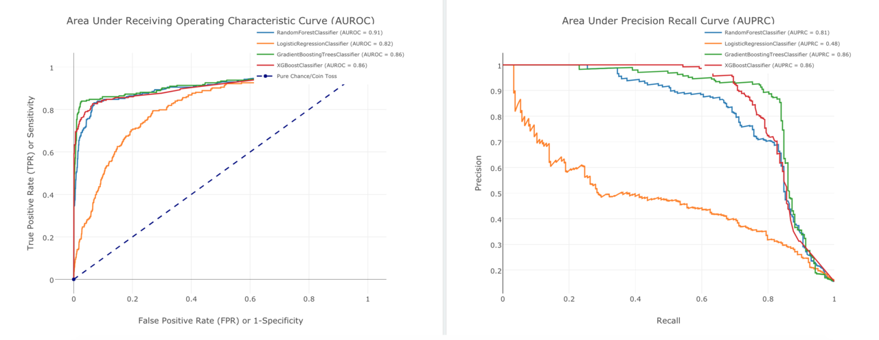
4

11. Deployment (Optional)
Deployment is the process of making the trained model available for real-world use. In this project, the model was deployed using Flask API. Users can input sensor data and get machine failure prediction.

Deployment Diagram
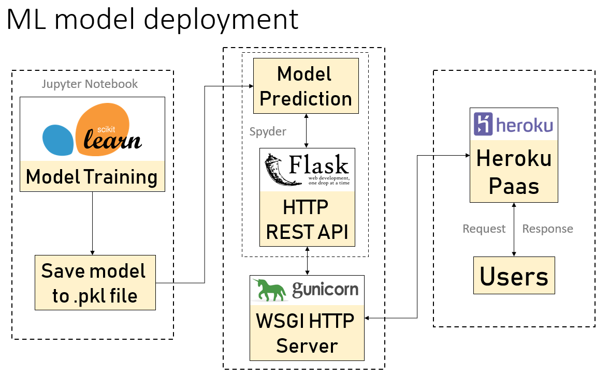
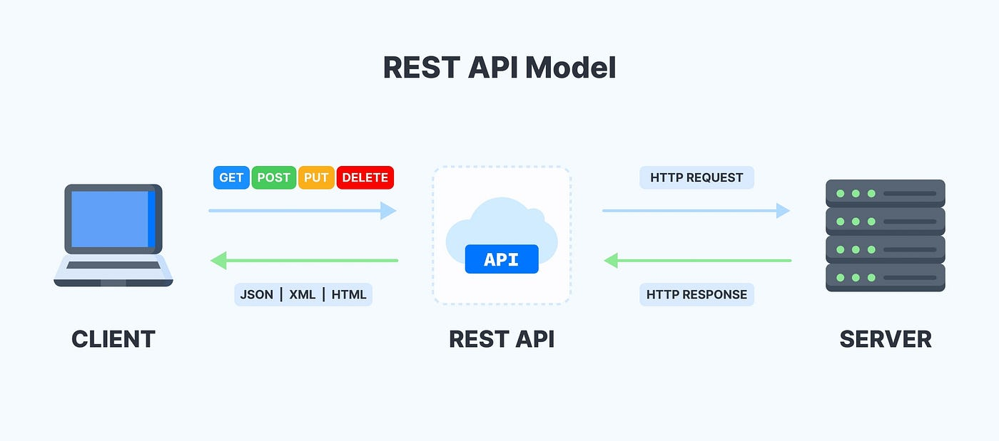
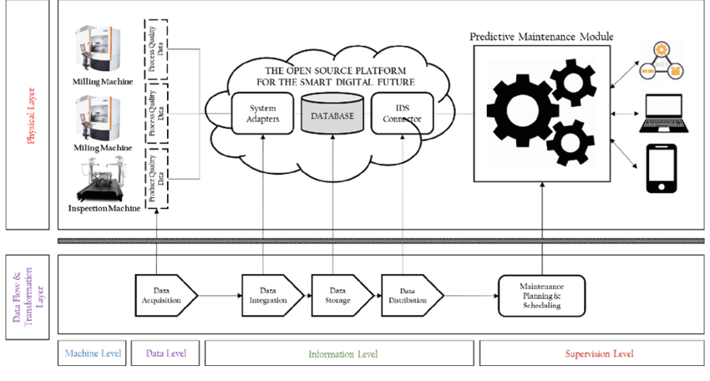
4

12. Conclusion
This project successfully developed a predictive maintenance system using machine learning. The model can predict machine failure accurately using IoT sensor data. This helps reduce maintenance costs and improve machine reliability.

13. Future Scope
Future improvements include integrating real-time IoT data, improving model accuracy, and using advanced deep learning models. This system can be applied in real-world industrial environments for better maintenance planning.

Bottom of Form

